**ATM Software Project**

Tables

1. Table 1 (static row number column number)

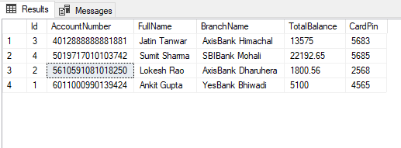

1. Table 2 (Transactions)



Stored Procedures

1. Procedure to get Balance

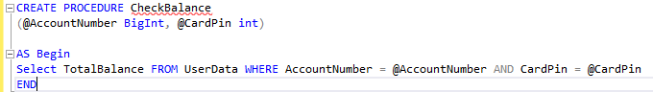

1. Procedure to update balance amount after withdraw money

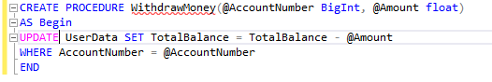

1. Procedure to update balance amount after deposit money.

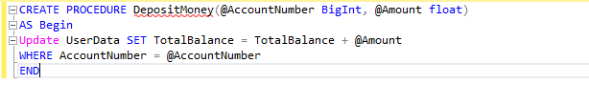

1. Procedure and insert the Transfer data in Transaction Table

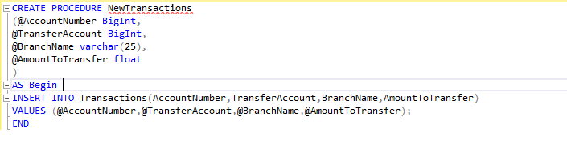

Project Screenshots

1. **Main Menu**

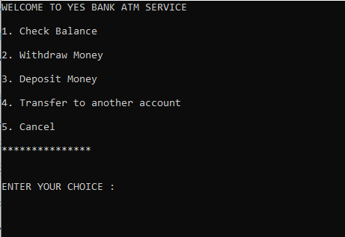

1. For Incorrect Option

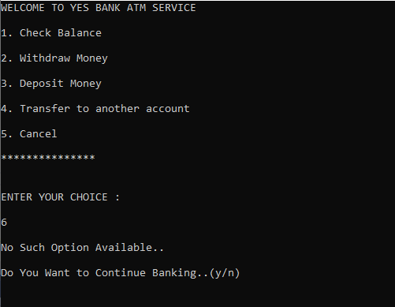

1. **Check Balance (Option 1)**

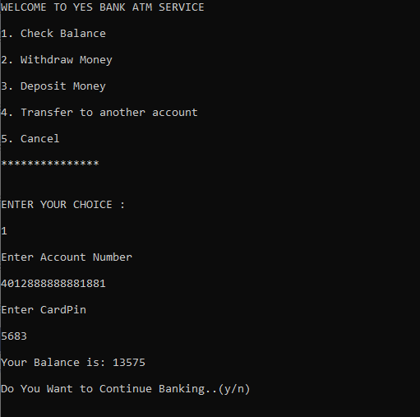

**Case : (When Credentials are Wrong)**

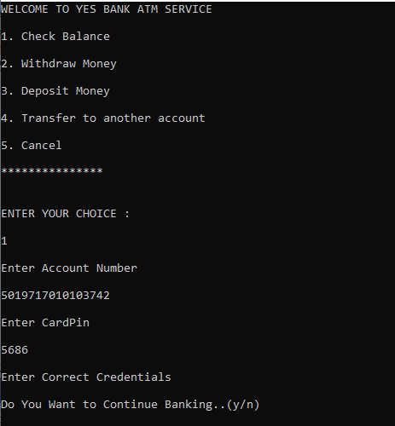

1. **Withdraw Money (Option 2)**

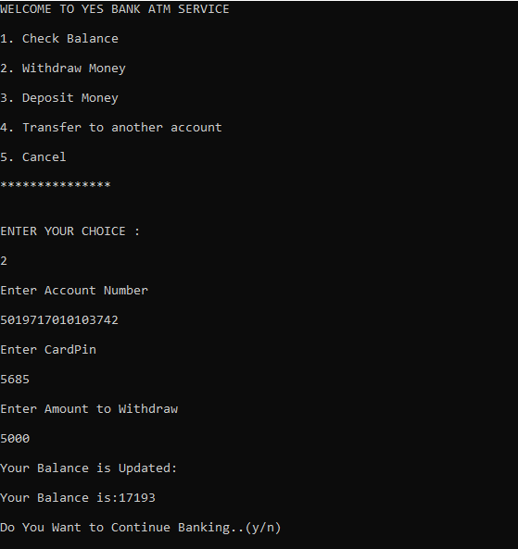

1. **Deposit Money (Option 3)**

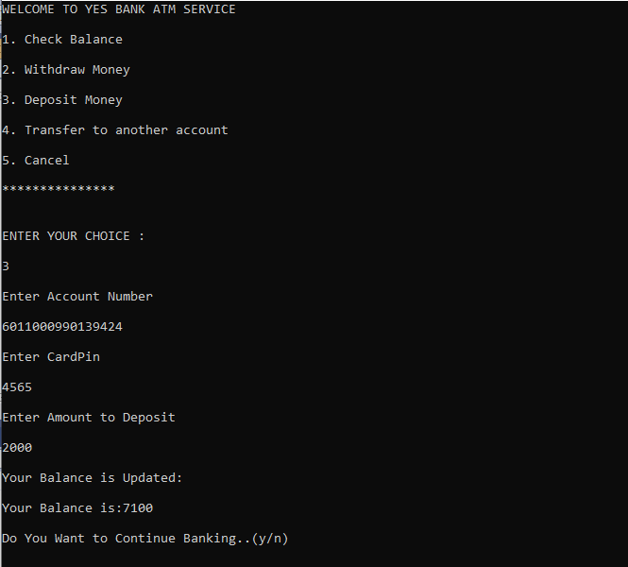

1. **Transfer Money (Option 4)**

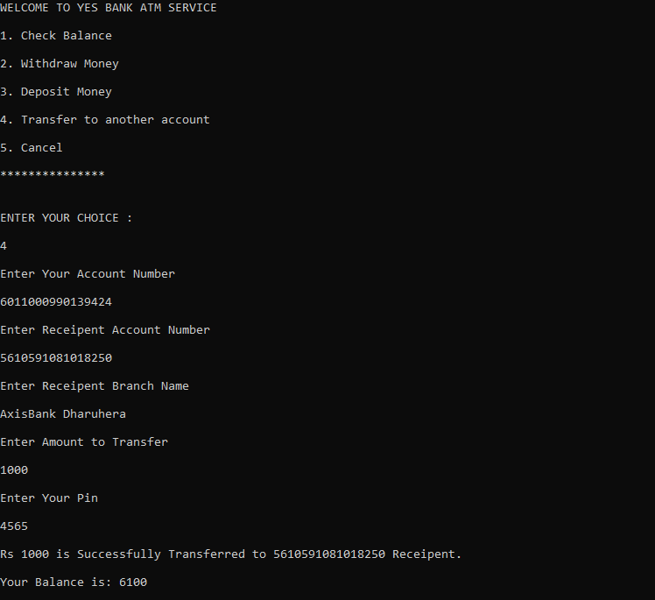

1. **Transfer Money (Option 4)**

Case: When Amount is Insufficient than the transferring amount

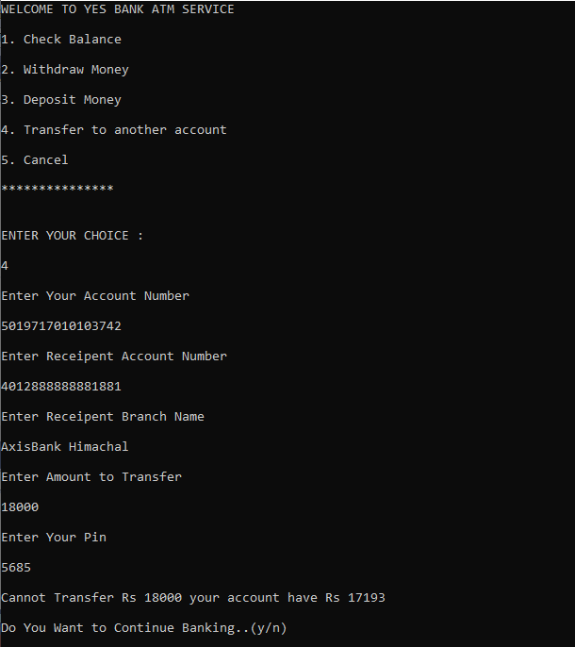

Now the Transaction Table will Updated. The Values are inserted after transactions due to transfer money

